Name:_____________________________________ 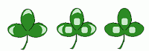

Honors Evolution Test Worley 3.18.15

1. Genetic Isolation A

2. Artificial Selection E

3. Selection Pressure C

4. Acquired Trait B

5. Natural Selection D

6. Homologous structures A

7. Sexual Selection B

8. Allopatric speciation E

9. Sympatric speciation C

10. Vestigal Structure D

A. When two groups of organisms differentiate enough that they can no longer interbreed

B. A trait which changes during an organism’s lifetime and is not genetically based

C. An environmental factor which causes a certain trait to become more or less common

D. A mechanism for change in populations (driven by the environment and differential survival based on fitness)

E. Breeding organisms with specific traits in order to produce offspring with desirable traits

A. Structural features with a common evolutionary origin

B. A mode of selection in which traits which allow an organism to better secure a mate are selected for or against

C. When two groups become reproductively isolated without a physical boundary

D. A body structure that has no function in a present day organism

E. When two groups become reproductively isolated with a physical boundary

11-20. Choose the best term for the following examples. Choices may be used once, more than once, or not at all.

a. Convergent Evolution b. Coevolution c. Parallel Evolution
d. Divergent Evolution e. Punctuated Equilibrium

11. A parasite and a host evolve together because they have a close ecological relationship. This is called an evolutionary arms race. Example: antibiotic resistant bacteria. B

12. Two related species live on different continents, but still look similar because they adapted in similar ways to similar environments. Example: Jaguars and leopards. C

13. Two UNRELATED species have similar adaptations that arose independently because they evolved in similar ways to similar environments. Example: sharks and dolphins. A

14. Horse evolution shows long stable periods of little evolution interrupted by brief periods of rapid change. E

15. Ants are the correct size and weight needed to open the flowers for the peony plant. The peony plant provides food for the ant and the ant fertilizes the peony’s flowers. B
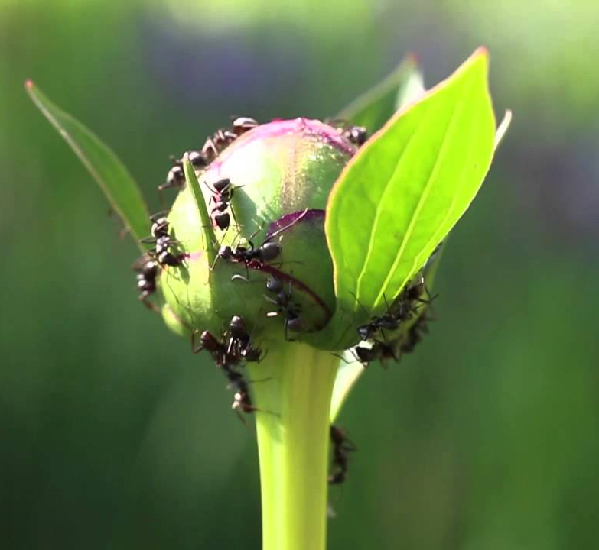

16. In the ocean surrounding Antarctica, there are fish that survive the cold water by using a molecule made of glycoproteins that circulates the blood and keeps it from freezing. Certain kinds of worms that live in the Arctic ocean also make antifreeze proteins that help them live in icy water. A

17. The Galapagos tortoises share a common ancestor, but have necks of different lengths (and different shell shapes) to best reach the food they need for their environment. D

18. Abrupt appearance of new species in the fossil records.
E

19. Associated with adaptive radiations.
E

20. The beaver in North America and the capybara in South America share a common ancestor, but have evolved over time to look different. D

21. Which of the following is the first piece of evidence that lead scientists to believe that organisms changed over time?

a. molecular clocks
b. stratigraphy
c. fossil record
d. embryology

22. Which scientist proposed the incorrect theory use & disuse to explain how organisms changed over time? (Giraffes stretching their necks over their lifetime to reach leaves and passing this trait on to offspring)?
a. Mendel
b. Darwin
c. Linnaeus
d. Lamarck

23. Which scientist performed the fundamental genetic research necessary to understand evolution?
a. Mendel
b. Darwin
c. Hutton
d. Lamarck
e. Wallace

24. In Artificial selection, what “chooses” the traits?

a. proteins
b. meiosis
c. humans
d. nature or the environment

25. In natural selection, what “chooses” the traits?
a. proteins c. humans
b. meiosis d. nature or the environment

26. One hypothesis states that humans are so genetically similar because a volcanic eruption killed off most of the population, so we are all related to the same small group of human ancestors. This would be an example of

a. genetic drift
b. natural selection
c. stratigraphy
d. genetic mutation

27. ______________________evolution refers to changes in a population over relatively short periods of time, while _______________________ evolution refers to changes in a population over longer periods of time.
a. Parallel; Convergent
b. coevolution; divergent
c. microevolution; macroevolution
d. macroevolution; microevolution

28. One scientist is studying the rate of mutation in a yeast species to learn more about the rate of mutations in cancer cells. This is an example of what kind of evolution?
a. microevolution
b. macroevolution
c. parallel evolution

d. convergent evolution
e. coevolution

29. If beetles have less to eat during a few months and their average body size as a population changes during one generation, is this evolution?
a. yes b. no

30. Which of the following is not a method to use for dating objects?

a. stratigraphy
b. use and disuse
c. molecular clocks
d. radiometric dating

31. In the peppered moth activity, which moth phenotype was the most fit when the bark was light?
a. light moths b. dark moths

32. In order for natural selection to take place, there are three conditions which must be met. Which of the following is NOT one of them?
a. an interbreeding population
b. variability in the population
c. some traits result in individuals being better suited to their environment
than others
d. there must be at least three related species in the area

33-37. Choose the correct for each example
a. directional selection b. Stabilizing selection
c. sexual selection d. Disruptive (diversifying) selection
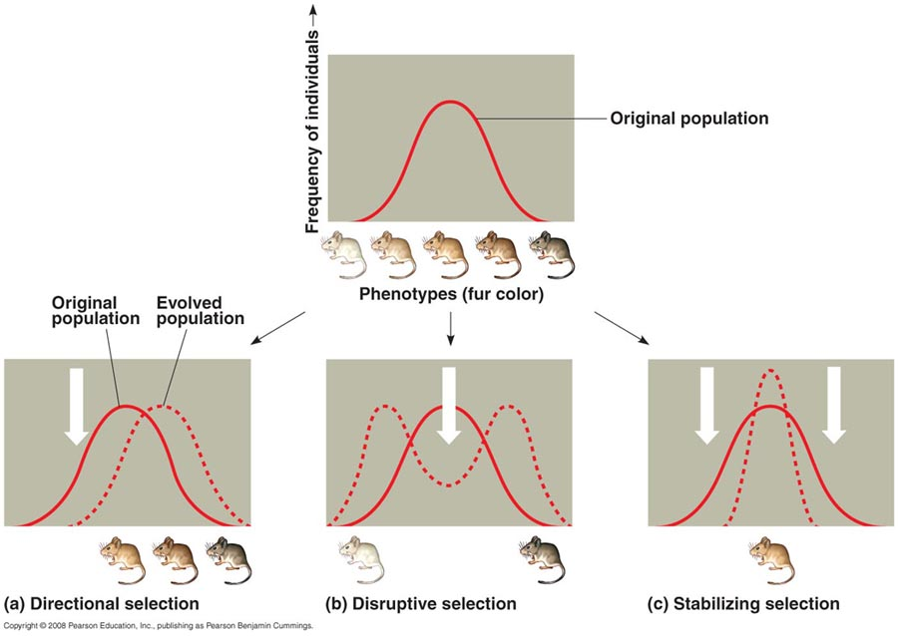
33 A 34D 35B
36. Male birds of paradise have very distinct mating dances, and the males and females have very different appearancesC

37. The environment changes, and now birds with the largest beaks are selected for. A

38. The method of determining the evolutionary relationship of organisms based on their early stages of development is called

a. embryology
b. cladistics
c. stratigraphy
d. phylogeny

Choose the correct scientist(s)

39. Marie CurieB

40. Alfred Russell WallaceE

41. Charles DarwinA

42. Hutton & LyellC

43. Thomas Malthus D

- Took careful observations over his lifetime to outline the principles of the theory evolution by natural selection.
- Conducted research on uranium which allowed scientists to quantitatively date rocks which were much older than the previously calculated age of the Earth
- Geologists who were proponents of the Earth being much older than previously thought
- Conducted research on human populations that focused on overpopulation of populations which led to competition for resources. This research helped to form the basis for the principles behind natural selection.
- Independently described natural selection while working in the British East Indies (now Indonesia).

44. The animals and plants of India are almost completely different from the species in nearby Southeast Asia. Why might this be true?
a. They have become separated by convergent evolution
b. The climates of the two regions are completely different
c. India is in the process of separating from the rest of Asia.
d. Life in India was wiped out by ancient volcanic eruptions
e. India was a separate continent until relatively recently.

45. A paleontologist estimates that when a particular rock formed, it contained 12 mg of the radioactive isotope potassium-40. The rock now contains 6 mg of potassium-40. The half-life of potassium-40 is 1.3 billion years. About how old is the rock?

a. 0.4 billions years
b. 0.3 billion years
c. 1.3 billion years
d. 2.6 billion years
e. 5.2 billion years

46. Which of the following pairs of structures is least likely to represent homology?
a. the skull of a cheetah and the skull of a house cat
b. the gill pouches of a mouse embryo and the gill pouches of a horse embryo
c. the mitochondria of a plant and those of an animal
d. the bark of a tree and the protective covering of a lobster
e. the genetic code of a bacterium and the genetic code of a human.

Short answer. Write your answers below.

47-54. Section 1. Choose 2.
A. If Darwin was NOT the first scientist to propose that organisms were not fixed and changed over time, why is his name synonymous with evolution today?

B. Describe how Darwin’s observations of organisms on the Galapagos Islands helped him to develop his theory of Evolution by Natural Selection. Please give specific examples.

C. Why were the following discoveries important to the validation of the theory of evolution by natural selection (and common descent of organisms)
1. Archaeopteryx
2. The Theory of Plate Tectonics (validated through sea-floor mapping)
3. Earlier, more simple fossils than the previous Trilobites and other
fossils of the Cambrian

D. List 4 pieces of evidence that we have that evolution has taken place and that all life has a common ancestor. Give a specific example of 2.

Part II. Choose 2.
A. In a population of pea plants, the T allele (tall) is 70% present in the population. Using this information calculate the genotypic frequencies you would expect to observe in the population. (p² + 2pq +q² = 1). Show your work. (You may use a calculator).
B. In some African populations the sickle-cell allele has a frequency of 0.2 (treat
this as the recessive allele although we know that this is a codominant trait). Using this value, calculate the percentage of the population that we would expect to have sickle cell anemia (homozygotes), and those with sickle cell trait (heterozygotes). Given that individuals with sickle cell trait have an increased resistance to malaria, does this make sense in terms of evolution? Why or why not?
C. The scarlet tiger moth has two phenotypes—white-spotted (dominant), or little spotting (recessive). In a population, there are 1500 white-spotted individuals, and 15 individuals with little spotting. Using this information, calculate the allelic frequencies (p & q) for this population. Show your work.

Bonus:
- What is sexual dimorphism? Give an example.

- What is a post-zygotic reproductive barrier? Give an example.

- What is the biological species concept? According to this concept would a horse and a mule (which produce sterile offspring) be considered one or two separate species?

- Name a “living fossil,” and describe what is meant by this term.

- Name a living “missing link,” and describe why this organism could be considered a missing link.

- In the 5 Kingdom system, what kind of organism are Monerans?

