1. Both insects and bats have developed wings, but they are not closely related. This is most likely an example of
a. co-evolution
b. convergent evolution
c. microevolution
d. genetic drift

2. Which best describes Lamarck’s older (& incorrect theory of evolution)?
a. Organisms change in their lifetime based on which organs they use or do
not use. They can then pass on these changes to their offspring.
b. Organisms change through natural selection as populations over long
periods of time.
c. Organisms experience many random genetic mutations, and this is the cause of evolution.
d. Organisms always change as a result of direct competition with another species.

3. Genetic Isolation A

4. Artificial Selection E

5. Selection Pressure C

6. Gene Pool B

7. Natural Selection D

8. Convergent evolution A

9. Parallel Evolution B

10. Coevolution C

A. When two groups of organisms differentiate enough that they can no longer interbreed

B. All of a population’s or species’ genes

C. An environmental factor which causes a certain trait to become more or less common

D. A mechanism for change in populations (driven by the environment and differential survival)

E. Breeding organisms with specific traits in order to produce offspring with desirable traits

A. Occurs when unrelated species occupy similar environments in different parts of the world, and evolve in a similar way.

B. When two related populations are physically separated but occupy similar niches, so evolve in a similar way.

C. When two species have a very close
ecological relationship and evolve
together. EX: flowering plants and
pollinators.

Choose the best term for the following examples.

a. Convergent Evolution b. Coevolution c. Parallel Evolution

11. A parasite and a host evolve together because they have a close ecological relationship. This is called an evolutionary arms race. Example: antibiotic resistant pathogens. B

12. Two related species live on different continents, but still look similar because they adapted in similar ways to similar environments. Example: Jaguars and leopards. C

13. Two UNRELATED species look similar because they evolved in similar ways to similar environments. Example: sharks and dolphins. A

14. Which of the following is the first piece of evidence that lead scientists to believe that organisms changed over time?
a. molecular clocks
b. stratigraphy
c. fossil record
d. embryology

15. Which scientist proposed the incorrect theory use & disuse to explain how organisms changed over time? (Giraffes stretching their necks over their lifetime to reach leaves and passing this trait on to offspring)?

a. Mendel
b. Darwin
c. Linnaeus
d. Lamarck

16. Which scientist proposed the correct theory of how evolution takes place?
a. Mendel
b. Darwin
c. Linnaeus
d. Lamarck

17. Which scientist performed the fundamental genetic research necessary to understand evolution?

a. Mendel
b. Darwin
c. Linnaeus
d. Lamarck

18. In Artificial selection, what “chooses” the traits?
a. proteins
b. meiosis
c. humans
d. nature or the environment

19. In natural selection, what “chooses” the traits?
a. proteins c. humans
b. meiosis d. nature or the environment

20. Darwin was the naturalist aboard the _________________________ which sailed to the _____________________ islands.

a. H.M.S Beagle; Galapagos b. H.M.S. Naturae; Galapagos
c. H.M.S Beagle; Cayman
d. H.M.S. Naturae; Cayman

21. If beetles have less to eat during a few months and their average size as a population changes during one generation, is this evolution?
a. yes b. no

22. Which of the following is not a method to use for dating objects?

a. stratigraphy
b. use and disuse
c. molecular clocks
d. carbon dating

23. In the peppered moth activity, which moth phenotype was the most fit (survived and reproduced more) when the leaves were light?
a. light moths b. dark moths

24. What adaptation allowed one peppered moth to be better suited to the environment than the other?

a. mimicry
b. mutation
c. predation
d. camouflage
e. symbiosis

25. 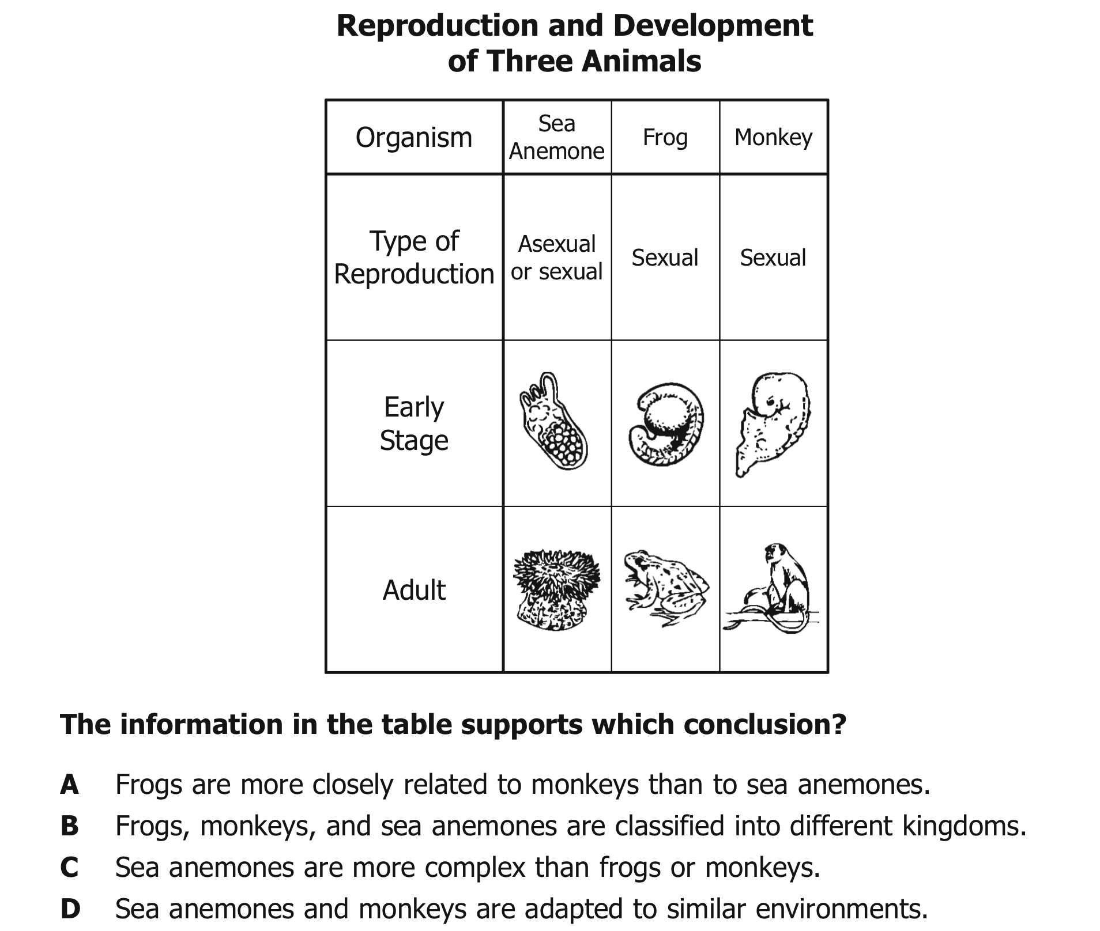

-- The above method of determining the evolutionary relationship of organisms based on their early stages of development is called embryology

A (We can tell this because their embryos look more similar to one another)
26. 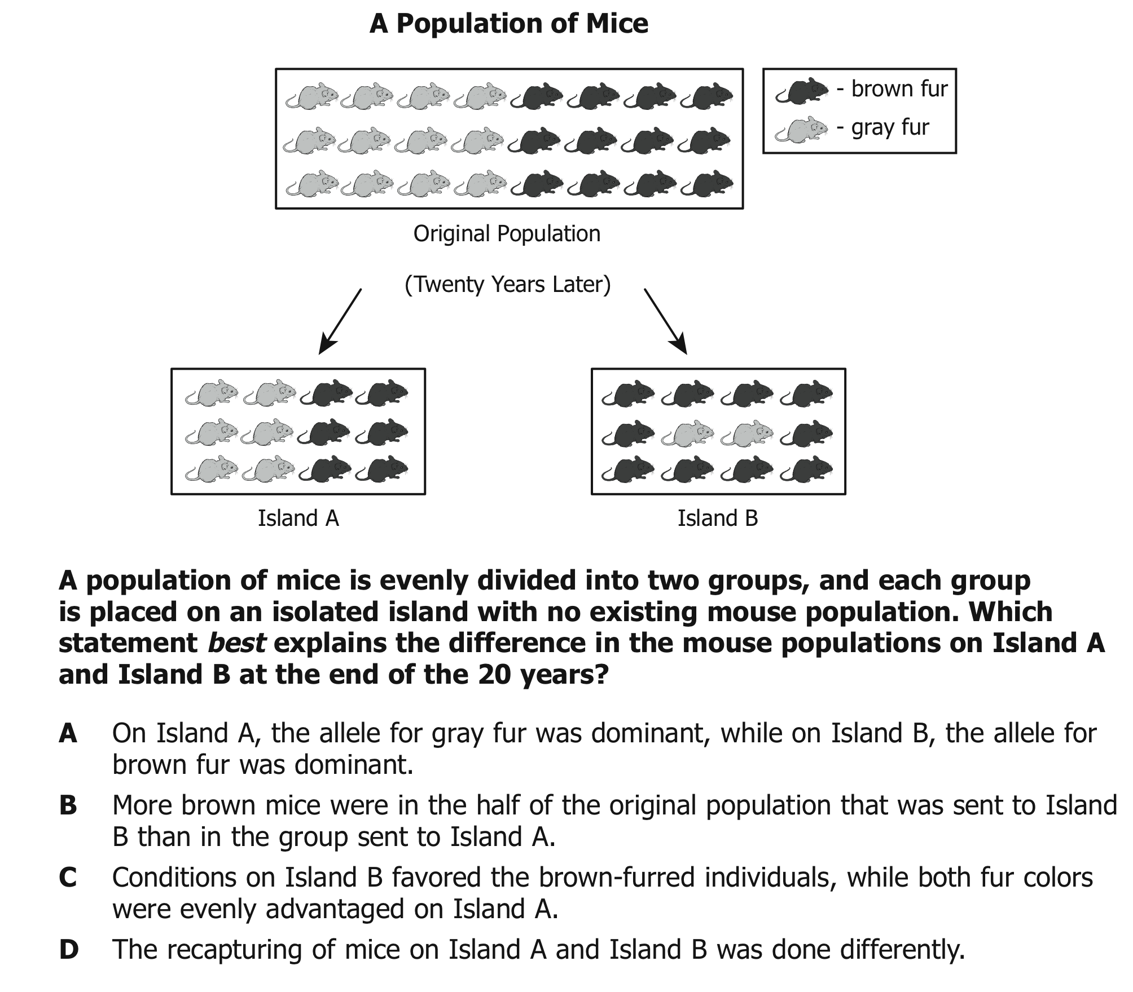

C

Sample Short answer questions. Write your answers below.

28-30. Explain what is meant by survival of the fittest and how it relates to
natural selection. Give a specific example about how it works. List at least two conditions necessary for natural selection to occur.

